EVERY MEAL WE PREPARE FOR YOU,

DEAR GUEST, WILL BE A

HEALTHY EXPERIENCE!

We have run our farm organically since its very beginning.
One of our highlights is our Galloway cattle
which provides us with tender and palatable beef.
Our potatoes come from the Mühlviertel region or Lungau
and are organically grown.
Only cold-pressed oils and purely fermented vinegars are used for our dishes.

We wish you a pleasant and entertaining evening with us!

Renate, Huwi, Caro, Luki & the entire team

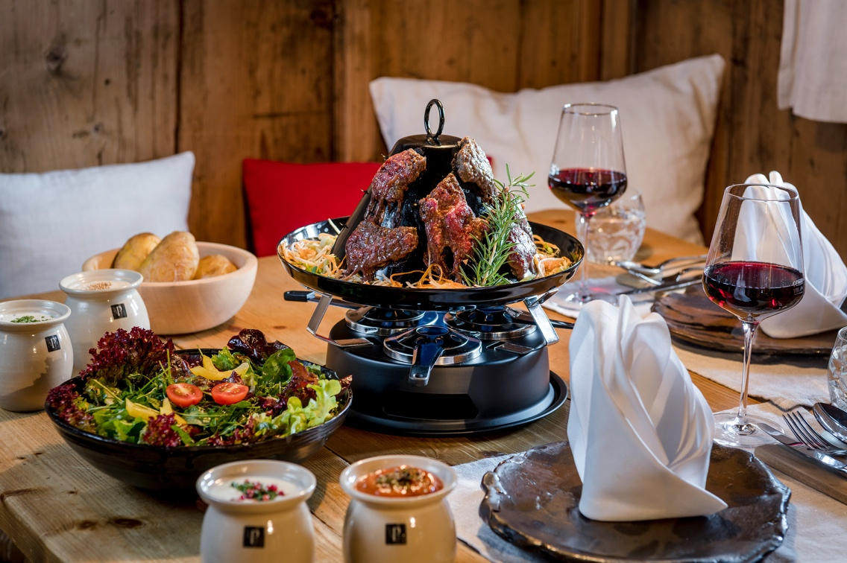

SOUPS
Real beef soup, liver dumplings, € 6,90
or pancake strips € 6,50
A, C, G, L

Wild garlic soup, Parmesan crisps € 8,50
G, H

SALADS
Small 'starter salad', garlic bread € 7,50
A, G
Tagliata of roast beef, lettuce, rocket salad, buffalo mozzarella,
parmigiano, garlic bread € 23,60
G, A, E, H

STARTERS
Smoked meat carpaccio, pastries € 22,50
A, G, H

Smoked trout mousse, baby leaf salad,

raspberry balsamic dressing, pastry €14,50

A, D, G

Sweet-sour hummus, whole-grain bread chips €14,50
A, H

Beef tartare from Black Angus fillet, turmeric onion,

truffle tramezzini €25,50

A,C, G, M

VEGETARIAN DISHES

All main courses are served with a bowl of crisp salad with garlic bread as a starter!

“Pinzgauer Kasnocken” (cheese nocks, roasted onions) € 19,50
A, C, G, L
Sweet potato-ginger purée, pak choi € 22,50
A, C, G, M

Chanterelle gnocchi, Parmesan foam € 25,50
A, C, G, E, H

Wild garlic gratin, paprika sauce (vegan) € 22,50
A, C, G, E, H

FISH DISHES
Pulpo, cherry tomato - olive risotto € 32,00
D, G

Warm, freshly smoked whole trout (about 300g)
with smoked trout mousse and smoked trout tartar

cranberry sauce, horseradish cream, Austrian lye rolls € 25,80
A, D, G

MAIN COURSES
All main courses are served with a bowl of crisp salad with garlic bread as a starter!

Medium grilled beef rump steak from Black Angus, wild garlic crust,
vegetables, mini potatoes € 34,50
A, E, G, H

Galloway goulash - legs or shoulders
butter pasta € 23,00
A, G
Roasted corn-fed chicken breast, Wild garlic risotto
C, G, C,
€ 32,00
Veal escalope Viennese Style with cranberry sauce and

parsley potatoes € 28,50
A, C, G

Pork escalope Viennese Style with cranberry sauce and € 22,00

parsley potatoes

A, C, G

Beiried Steak from Black Angus (240g)

Port wine sauce, baked potato with chive sauce € 38,00

G, M

Fillet Steak from Black Angus (240g), port wine sauce,
baked potato with chive sauce € 47,00
G, M

OUR SPECIALITIES

On advance order only

“HUT” DINNER (minimum 2 persons) p. P. € 31,00
Before this unique BBQ experience, you’ll be served a bowl of crisp salad.

Three burners heat the Tartar’s hat where your choice of strip loin steak,

rump steak and pork loin is barbecued.

The hat’s brim is filled with beef soup and Julienne vegetables.

To round it all up we serve baked potatoes with a choice of barbecue,

chives and garlic sauce.
A, C, G, L, M
Extra plate of mixed meats (210g) € 11,50
Extra plate of beef only (210g) € 14,50

RIB DISHES p. P. € 22,00
Salad with garlic bread followed by delicious spare ribs

with baked potatoes and chive sauce

M, G, L

Extra plate of spare ribs € 13,50

ROASTED OX (4 persons) p. P. € 39,00

Salad with garlic bread followed by pink-roasted saddleback

of either Galloway or Angus cattle oven-baked at a low temperature

for about eight hours.

Served with roast potatoes and red cabbage or roasted vegetables

G, L

OUR DESSERT RECOMMENDATIONS
Homemade ice cream made with milk from Salzburg’s mountain farms and Leogang yoghurt

Affogato al caffè € 4.90
G

Scoop of bourbon vanilla ice cream € 3.90
G

Scoop of Mei-Muich yoghurt ice cream € 3.90
G

Vanilla ice cream with fresh strawberry and mint ragout, whipped cream
G, H € 7.50

Yoghurt ice cream with lemon olive oil from Istria, whipped cream € 7.50
G

Vanilla ice cream with pumpkin seed oil € 7.50
G

Vanilla ice cream with warm Nutella € 7.50
G, E, H

Banana split: vanilla ice cream, banana, Nutella & toasted flaked almonds, whipped cream G, H, E € 9.50

Blueberry & Yoghurt
Yoghurt ice cream, blueberry compote, blueberry yoghurt, fresh blueberries, whipped cream G € 9.50

Amarena cherry € 9.50
Yoghurt ice cream, Amarena cherries, dark chocolate shavings, whipped cream
G

Yoghurt and passion fruit € 9.50
Yoghurt ice cream, passion fruit purée, coconut chips, white chocolate shavings, whipped cream
G

Strawberry tiramisu with fresh strawberry and mint ragout € 11.50
A, C, E, G, H

Trio of mousses white & dark chocolate, strawberries € 10.00
G, C, E

Dessert platter € 12.50
Curd dumplings, butter and sugar crumble, cream slices,
fruit, spiked plums, vanilla ice cream, pumpkin seed oil, raspberry purée
A, E, G

Kaiserschmarrn with raisins & roasted plums € 13.50
A, C, G

NON ALCOHOLIC DRINKS

Coke light 0,33 l € 3,70
Bottle of Almdudler 0,33 l € 3,70
Bottle of sparkling water 0,33 l € 3,50
0,75 l € 5,90
Homemade grapefruit soda 0,50 l € 5,00
Homemade Ginger soda 0,50 l € 5,00
Homemade ice tea citron 0,50 l € 5,00
Orange or red currant with soda 0,25 l € 2,90
0,50 l € 4,20
Orange or red currant juice 0,25 l € 3,50
Cloudy “cox orange” apple juice 0,25 l € 3,70
0,50 l € 5,00
0,70 l € 8,50
Cloudy “cox orange” apple juice 0,25 l € 3,50
Cloudy “cox orange” apple juice with soda 0,50 l € 5,00

Coke, Sprite, Fanta 0,25 l € 3,50
0,50 l € 5,20

Red Bull 0,25 l € 4 ,90

BEER
Trumer draught Pilsner 0,20 l € 3,10
0,30 l € 4,40
0,50 l € 5,20

Traunsteiner wheat beer 0,30 l € 4,60
0,50 l € 5,40

Light wheat beer 0,50 l € 5,40
Dark wheat beer 0,50 l € 5,40

Non-alcoholic beer 0,30 l € 4,10
Non-alcoholic Traunsteiner wheat beer 0,50 l € 5,10
Non-alcoholic Radler 0.50 l € 4.40

WINE

ROSÈ BF "the little elephant" Pia Strehn 1/8 l € 6,20

🍷🍷🍷 🍷🍷🍷 🍷🍷🍷

Grüner Veltliner, Leo Müller Ried Neuberg 1/8 l € 6,20
Chardonnay, Bernhard Gschweicher Lower Austria 1/8 l € 6,20
Riesling Elements, Martin Müller Elements
Lower Austria 1/8 l € 6,20
Sauvignon Blanc, Silly Southern Styria 1/8 l € 6,20

🍷🍷🍷 🍷🍷🍷 🍷🍷🍷

Blaufränkisch, Andreas Unger Burgenland 1/8 l € 6,40
Cuvée Classic, Scheiblhofer, Burgenland 1/8 l € 6.40
Merlot Selection, Jacky Klein Burgenland 1/8 l € 6.40
Zweigelt, Anton Bauer Feuersbrunn 1/8 l € 6.40

APERITIF

Non-alcoholic Aperol Spritz 1/4 l € 6.40
Non-alcoholic Hugo 1/4 l € 6.40
Non-alcoholic Rebels Wild Berry 1/4 l € 6.40
Glass of Prosecco £5.80
Glass of Prosecco with elderflower syrup £6.00
Testarossa (Prosecco with strawberry syrup) £6.20
Glass of Shiki Miki Rosé Brut £6.00
Sweet spritzer 1/4 l £5.50
Sour spritzer 1/4 l £5.20
Aperol Spritz with wine 1/4 l £7.50
Aperol Spritz with Prosecco 1/4 l £7.90
Campari Spritz with Prosecco 1/4 l £7.90
Hugo (Prosecco / elderflower cordial / mint) 1/4 l £7.90
Strawberry Hugo 1/4 l € 7.90
Lavender Spritz 1/4 l € 7.30
Lillet Wild Berry 1/4 l € 7.90
Limoncello Spritz 1/4 l £7.90
Campari Orange £6.90
Campari Soda £6.20
Martini Bianco 4cl £5.20

Fine spirits | Liqueurs

Fine spirits matured/refined in wooden barrels #Enjoyment#ELEGANCE#A treat for the palate
2 cl.

🍷🍷🍷 Original Wachau apricot wood, L. Müller Lower Austria. ‘From the MAGNUM’ 5.60
Aged for 2-4 years in barrels | dried apricots | balanced | subtle wood undertones
🍷🍷🍷 Old plum, Gölles, Styria 5.60
Aged for 8 years in barrels | ripe wood undertones | smooth | sweet and spicy plum fruit

Fine spirits Clear #Fruity#Charming#NUANCED

🍷🍷 Orig. Wachauer Marille clear, L. Müller, Lower Austria 4.90
Glass balloon | full, fine varietal fruit | pure apricot | fine length | HARMONY | enjoyment

🍷🍷 Williams pear, L. Müller, Lower Austria
Glass balloon | Juicy sweetness | Pure pear fruit body | Seductive | Fruity 4.90

🍷🍷 Heart cherry, A. Gölles, Styria 5.20
Aged for 2 years in a glass balloon | elegant | fine cherry notes | fruity | clear

🍷🍷 Raspberry with apple, Herzog, Salzburg 5.60
🍷🍷 Blood orange, Herzog, Salzburg 5.60
🍷🍷 Nusserl, Herzog, Salzburg 5.60

Spirits
🍷 Hausbrand / Obstler, Pinzgau 4.20

Liqueurs #Fruit#Sweet#Uncomplicated

🍷 Edel Stoff Zirbe, Priesteregg Edition Harry Albel, Salzburg 5.80
🍷 Red wine liqueur L. Müller, Lower Austria 4.90
🍷 Chocolate chilli liqueur Herzog, Salzburg 4.90
🍷 Baked Apple Liqueur Herzog, Salzburg 4.90
🍷 Holy Hazel Nut Liqueur Harry Albel, Salzburg 5.80
🍷 Limonchello Liqueur Harry Albel, Salzburg 5.50

🍷 Fruity and charming | 🍷🍷 Balanced – clear fruit variety | 🍷🍷🍷 Elegantly refined, stored in wooden barrels

LONG DRINKS

Gin and Tonic € 9.50
Gin and Tonic Royale/ Tanqueray Blackcurrant Royale Gin/ € 9.50
Gin and Tonic Sevilla / Tanqueray Flor De Sevilla Orange Gin/ € 9.50
Skinny Bitch/Vodka-Soda-Lemon Juice € 9.00
Vodka Lemon € 9.00
Vodka Bull € 9.20
Bacardi Cola € 9.20
Havana Cola € 9.50
Pampero Cola € 9.50
Cuba Libre € 9.70
Jack Daniels Cola € 9.70
Bulleit Bourbon Cola € 9.50
Whisky Bull € 9.70
Moscow Mule € 10.50
London Mule € 10.50
Zirben Mule € 10.70
Flying Hirsch € 8.90
Americano € 10.50
Caipirinha € 11.50
Caipiroska € 11.50
Daiquiri € 10.70
Negroni € 11.50
Espresso Martini € 13.50

SELECTED LEAF TEAS € 4,50
from Demmer T-Bag

FRUIT TEA
Aromatizing fruit tea blend
T-bag forest fruit cocktail

GREEN TEA
T-Bag BIO Green Manjolai

HERBAL TEA
T-Bag BIO Vital Oasis
T-Bag ginger lemon

BLACK TEE
T-Bag Assam

HOT DRINKS
Afro Ristretto € 2,70
Afro Espresso € 3,20
Afro coffee (cup) € 3,60
Cappuccino € 4,10
Café Latte € 4,50
Hot chocolate with whipped cream € 4,40
Affogato € 4,70

ABBREVIATIONS FOR ALLERGENIC SUBSTANCES

CODE | BRIEF DESCRIPTION | PRODUCT EXAMPLES
A | Gluten-containing cereals | Wheat, rye, barley, oats, spelt, kamut or hybrid strains thereof; derived products
B | Crustaceans | Crabs, shrimps, prawns, crawfish, lobsters, scampi and products thereof
C | Egg | Eggs and products thereof
D | Fish | All kinds of fish, caviar and products thereof
E | Peanuts | Peanuts and products thereof
F | Soya | Soybeans and products thereof
G | Milk and lactose | Milk from animals such as cows, sheep, goats, horses and products thereof
H | Nuts | Almonds, hazelnuts, walnuts, cashew nuts, pecans, Brazil nuts, pistachios, macadamia or Queensland nuts and products thereof; apart from nuts for the production of alcoholic distillates, including ethyl alcohol of agricultural origin
L | Celery | Celery and products thereof
M | Mustard | Mustard and products thereof
N | Sesame | Sesame seeds and products thereof
O | Sulphites | Sulphur dioxide and sulphites in concentrations greater than 10 mg/kg or 10 mg/l as total SO2 present, calculated for products ready for consumption or returned to their original state according to manufacturer's instructions
P | Lupines | Lupines and other products thereof

